Jiangsu Guomao Reducer Co., Ltd.

Jiangsu Guomao Reducer Co., Ltd., founded in 1993, is a high-tech enterprise integrating R&D, manufacturing and sales.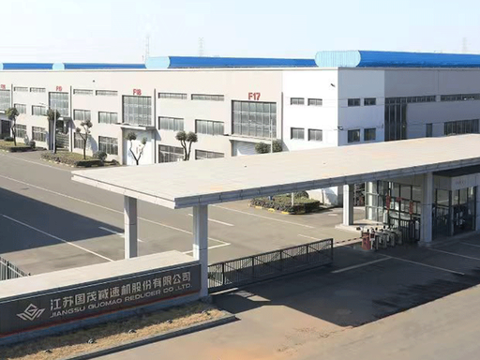
Guided by our vision to become a world-class power transmission solution provider, Guomao boasts an industry-leading product portfolio consisting of more than 12 major series and tens of thousands of specifications, including standard, special-purpose, medium and large non-standard models. We are widely acknowledged as a benchmark manufacturer and service supplier of reducers and variable speed equipment within China’s general machinery industry.

Our core products cover modular gear motors, cycloidal pinwheel reducers, industrial gearboxes, planetary gear reducers, harmonic reducers, RV reducers and AC servo motors, capable of satisfying the selection requirements of customers across diverse industries
.